Jira Automation (Non-Admin)

Jira Automation helps reduce manual work by automatically performing actions based on defined conditions.
Non-admin users have access to basic automation features that improve efficiency without requiring system-level permissions.

Automation Available to Non-Admins
Non-admin users can use limited automation within their projects.
Common capabilities include:
- Creating simple automation rules
- Automating repetitive actions
- Applying rules only within their own project
These automations help teams save time while following existing project configurations.

Creating Simple Automation Rules
Non-admins can create basic rules using triggers, conditions, and actions.
Examples include:
- Automatically assigning an issue when it is created
- Updating status based on field changes
- Adding labels or comments automatically
These rules help streamline everyday workflows without deep configuration.

Limitations of Non-Admin Automation
Non-admin automation has certain restrictions.
Limitations include:
- Cannot modify global workflows
- Cannot change project schemes
- Cannot access advanced automation settings
These limitations ensure system stability and consistency.

When Admin Support Is Required
Admin involvement is needed when:
- Workflow changes are required
- Custom fields must be created or modified
- Global automation rules are needed
- Project-wide or cross-project automation is required
Understanding these boundaries helps in knowing when to raise requests to Jira administrators.

Hands-On Practice:

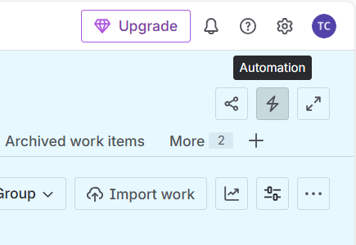
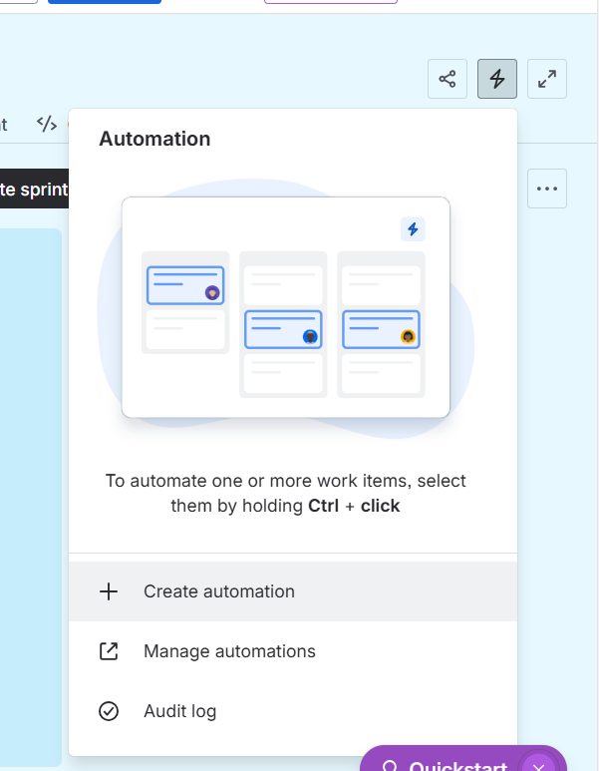

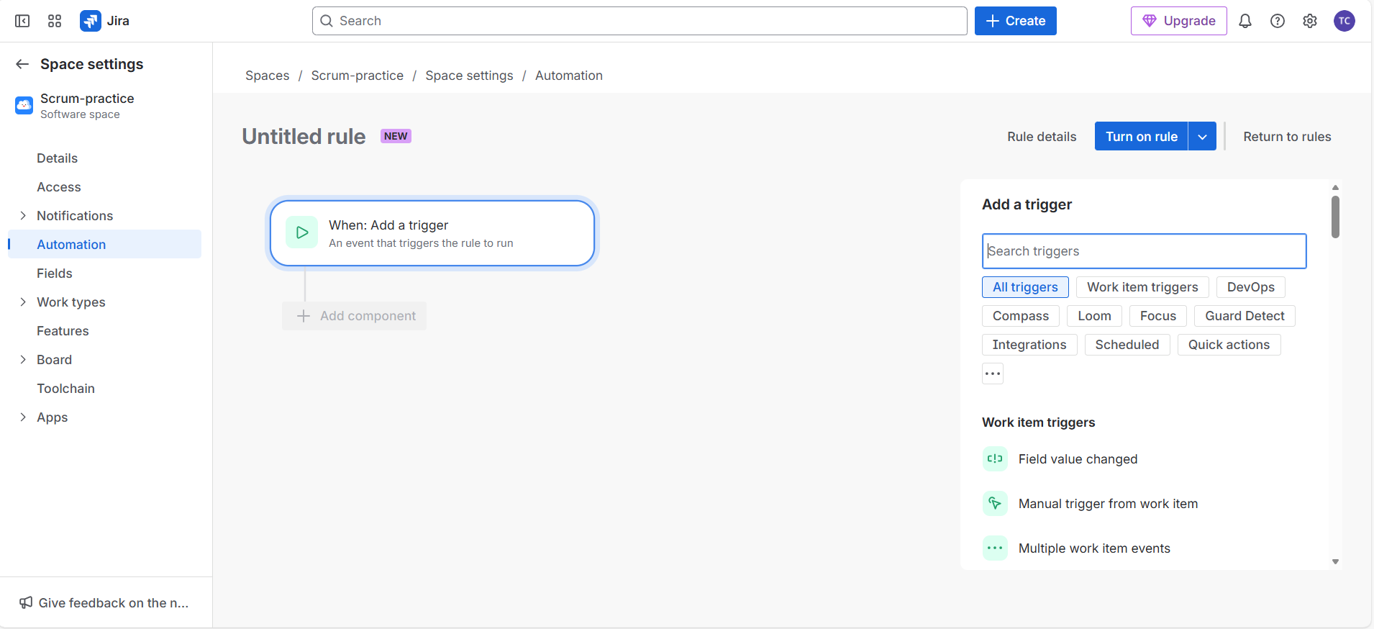

  - In the above image finally you can see the automation interface with all kind of components

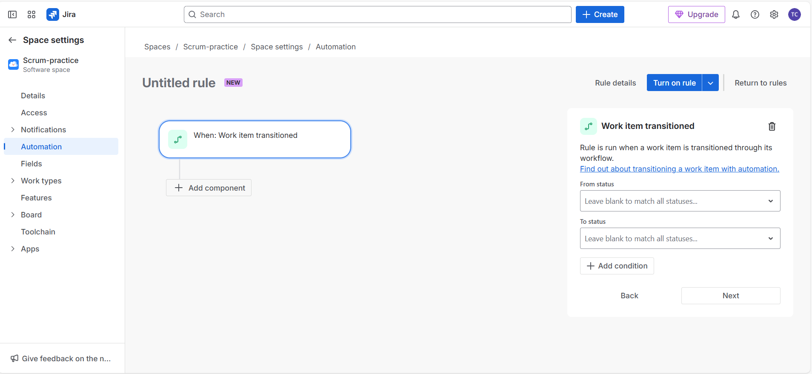

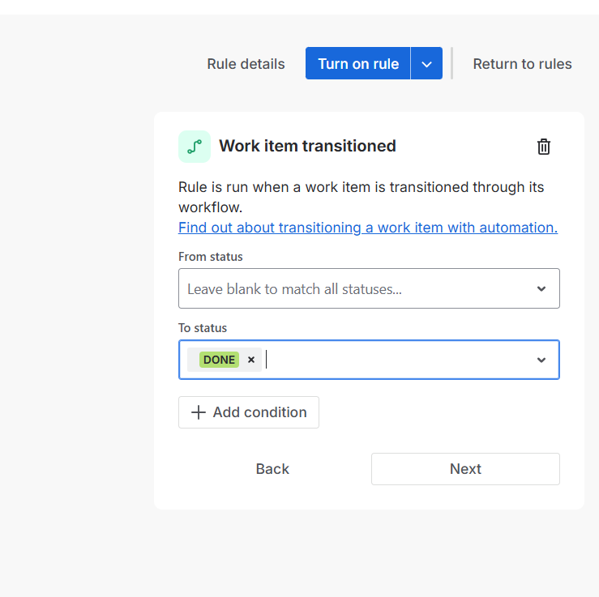

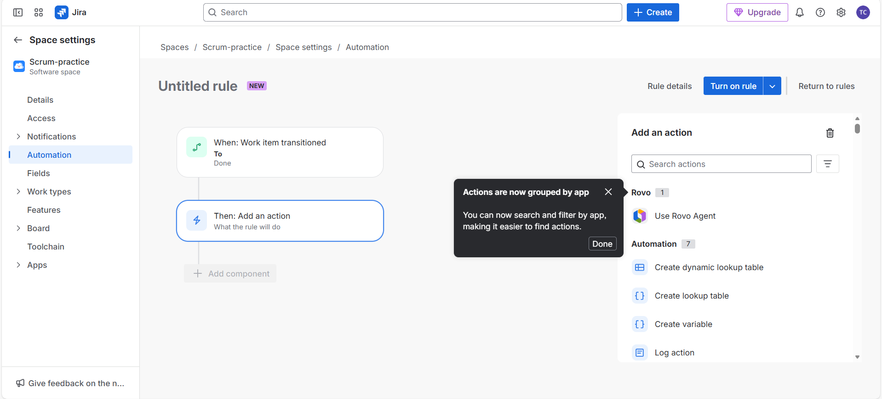

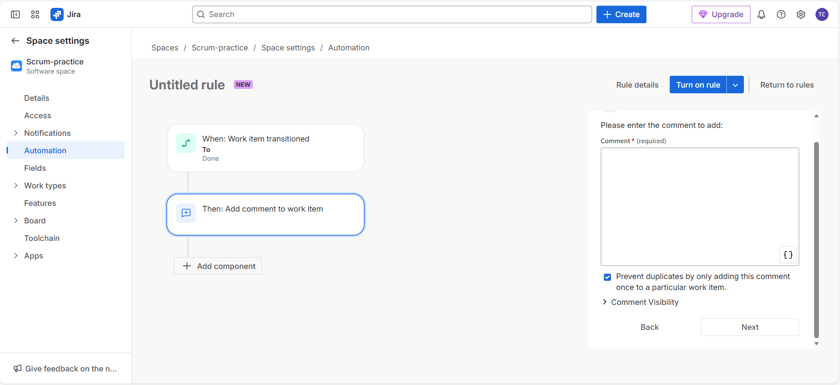

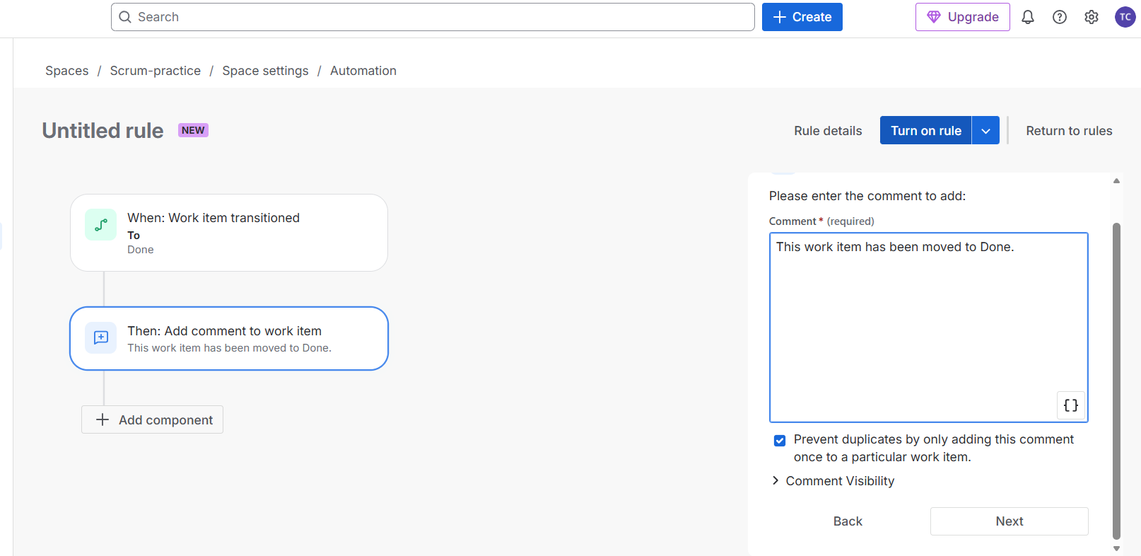

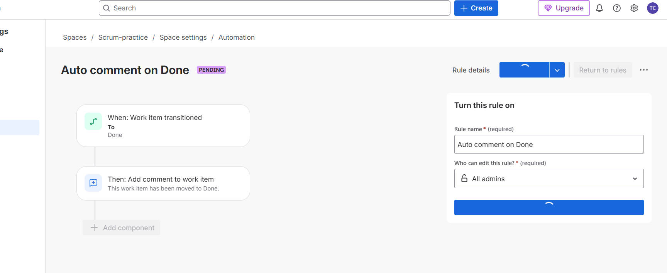

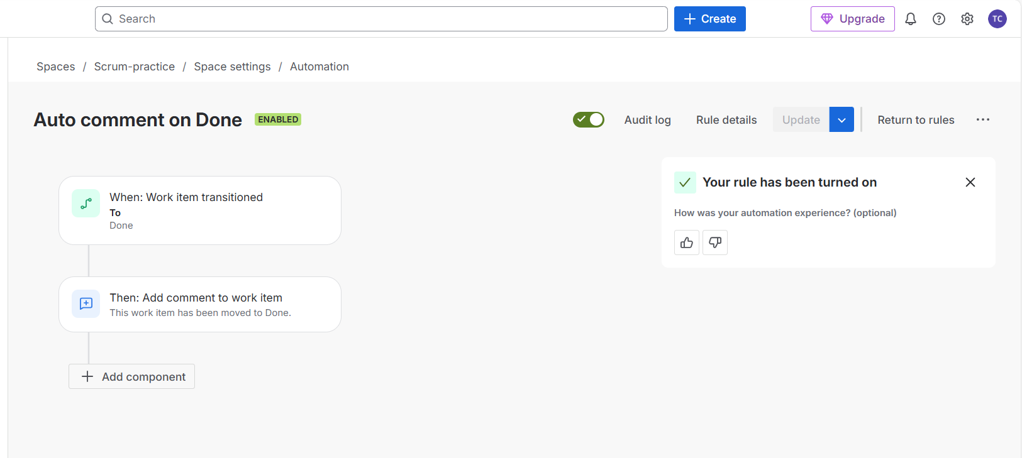
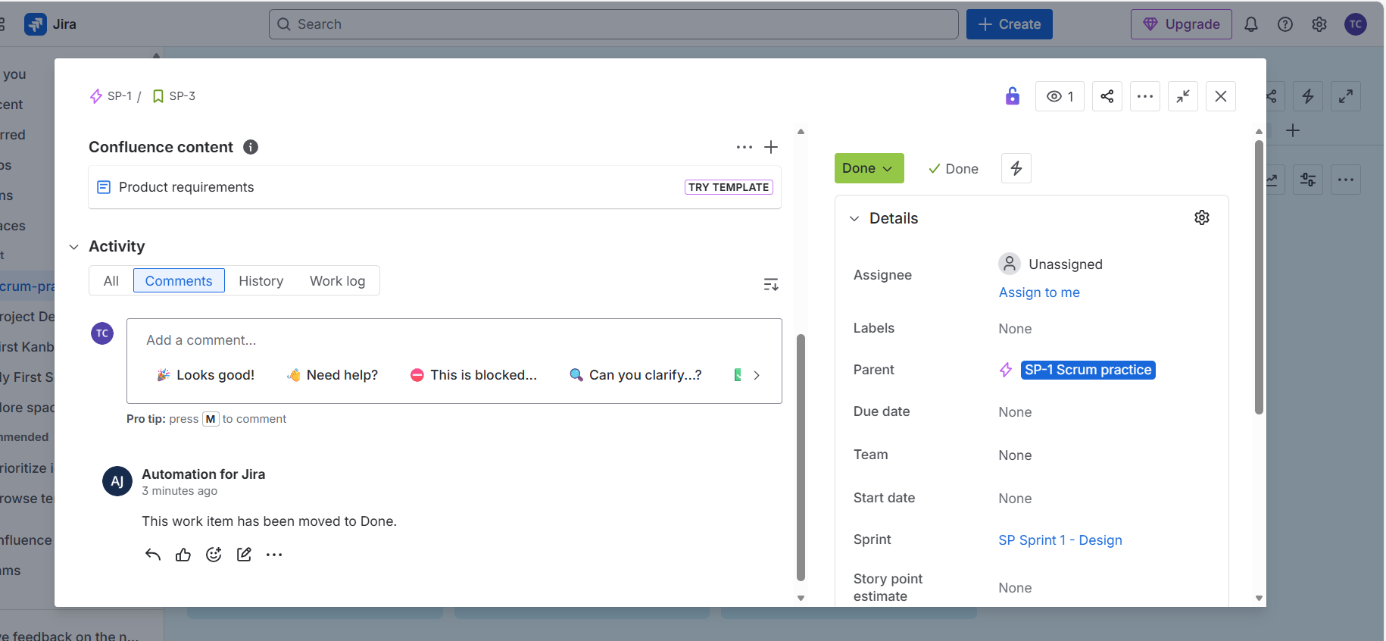
Process Followed in the Above Automation
Automation Trigger Used
On the automation screen:
- When: Work item transitioned
- To: Done
This means the automation will run whenever a work item is moved to the Done status.
Initially, there was an additional block:
- Status is one of …
This condition was unnecessary and confusing for a beginner-level automation, so it was removed to keep the rule simple.

Learning Objective
Goal:
When a Story or Bug is moved to Done, Jira should automatically add a comment to that issue.

Step 1: Remove the Unnecessary Condition
- Locate the block that says “Status is one of …”
- Click the Delete (trash) icon on that block
- After deleting it, only one block should remain:
  - When: Work item transitioned → To Done
At this point, no other conditions should be added.

Step 2: Add a Single Action
- Click Add component
- Select Action
- From the list of available actions, select Add comment
- If it is not immediately visible, scroll down and locate it manually

Step 3: Enter the Comment Text
In the Comment field, enter the following text:
- This work item has been moved to Done.
No other fields or options need to be changed.

Step 4: Enable the Automation Rule
- Click Turn on rule from the top-right corner
- When prompted to name the rule, enter:
  - Auto comment on Done
- Save and activate the rule
The automation is now active.

Step 5: Test the Automation
- Navigate to your Scrum board
- Create a new Story or use an existing one
- Move the issue through the workflow:
  - To Do → In Progress → Done
- Open the issue and check the Comments section
If the setup is correct, the comment should appear automatically.

Clarification: What Does “Open the Issue” Mean?
In Jira terminology:
- An issue refers to any Story, Task, or Bug
To open an issue:
- Click on the issue card on the board
- This opens the issue details page

How to Open an Issue (Simple Steps)
- Go to the Scrum board
- Locate any issue card (Story, Task, or Bug)
- Click once on the card
You are now viewing the issue details.

Where to See the Automation Result
Inside the issue details page, scroll down to find:
- Description
- Activity
- Comments
The automation-generated message will appear in the Comments section.

Important Question: Does Automation Apply to All Projects?
Clear Answer:
Automation rules are limited to the project in which they are created.

In This Case
The automation was created under:
- Scrum-practice → Project settings → Automation
This means:
- The rule works only for the Scrum-practice project
It does not affect:
- Other Scrum projects
- Kanban projects
- Any other Jira projects or spaces

Why Jira Restricts Automation Per Project
Each project may belong to a different team or purpose.
For example:
- One project may belong to a development team
- Another may belong to a QA or testing team
If automation rules applied globally:
- Incorrect comments could be added
- Issues could be updated unintentionally
- Workflow behavior would become unpredictable
To avoid this, Jira isolates automation rules at the project level.

If you want, next time we can:
- Go deeper into automation conditions and smart values
- Compare admin vs non-admin automation
- Practice real interview-style automation scenarios

Working on other automation in the existing rule defined:
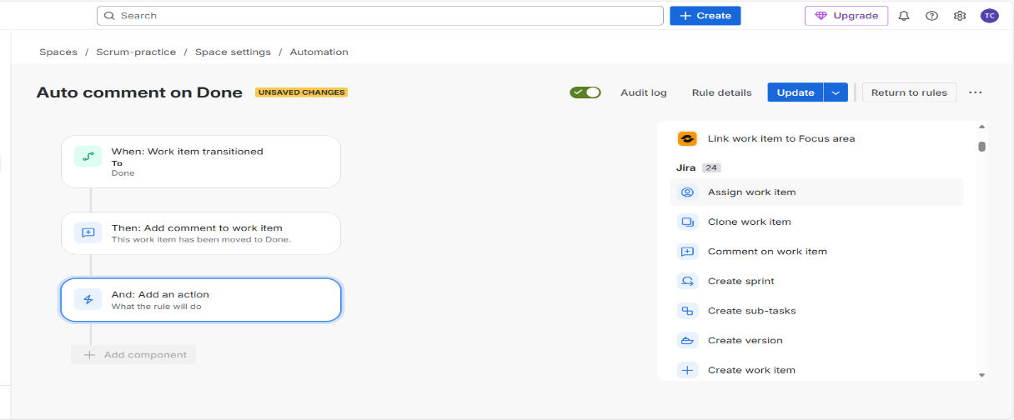

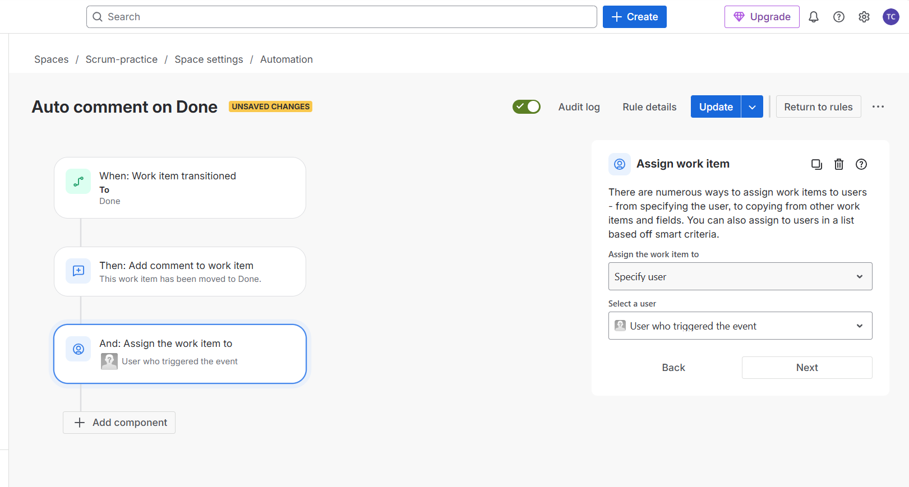

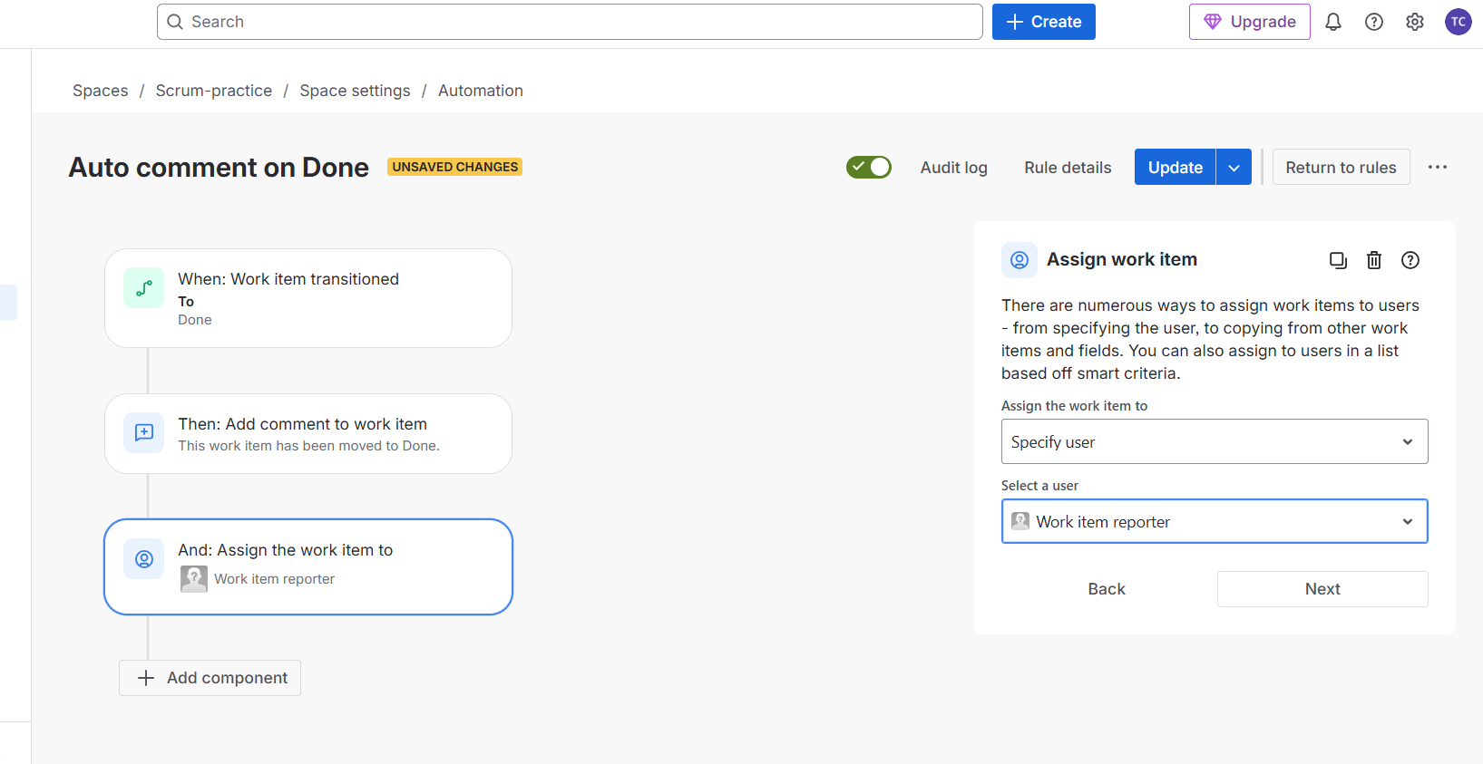

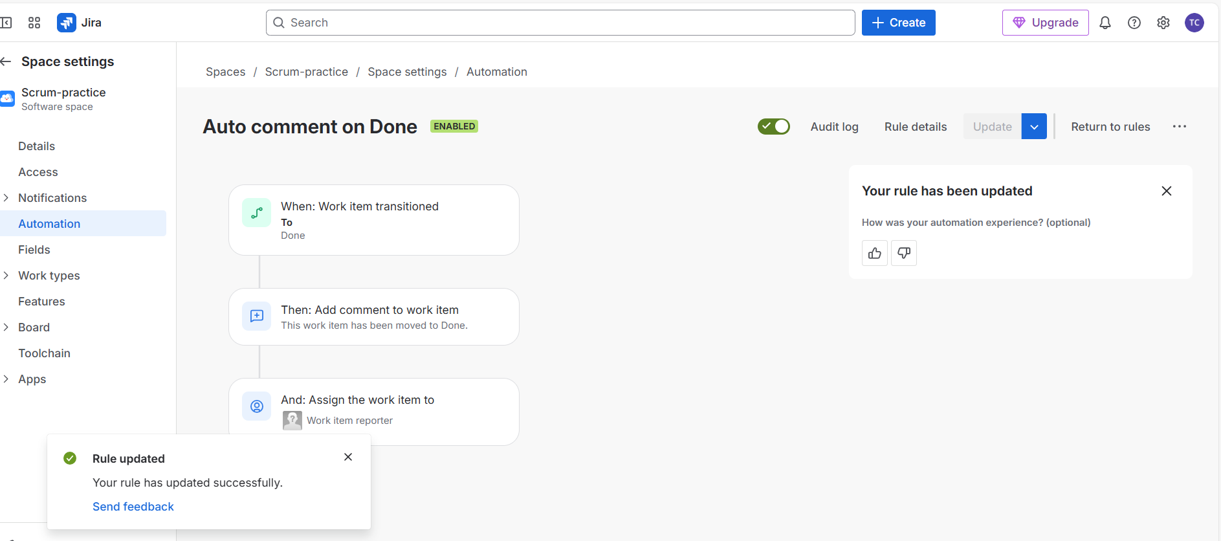
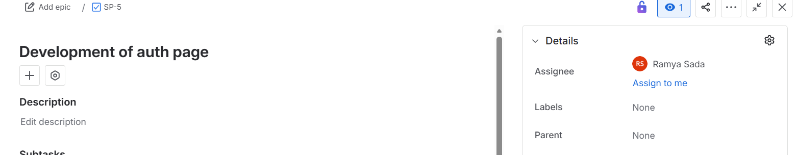

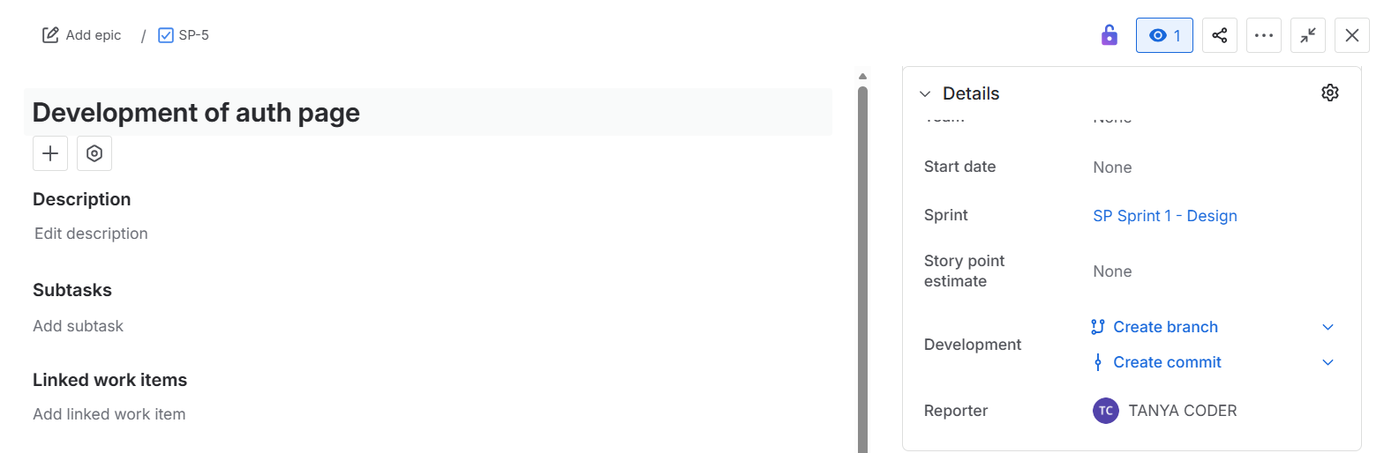

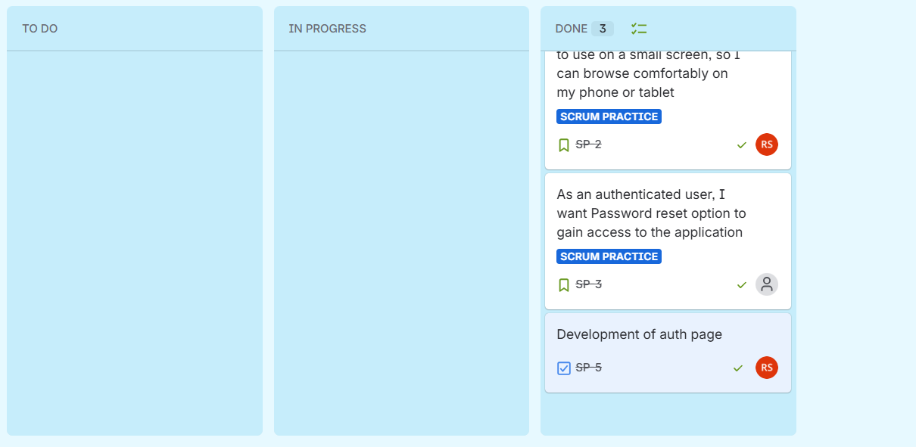

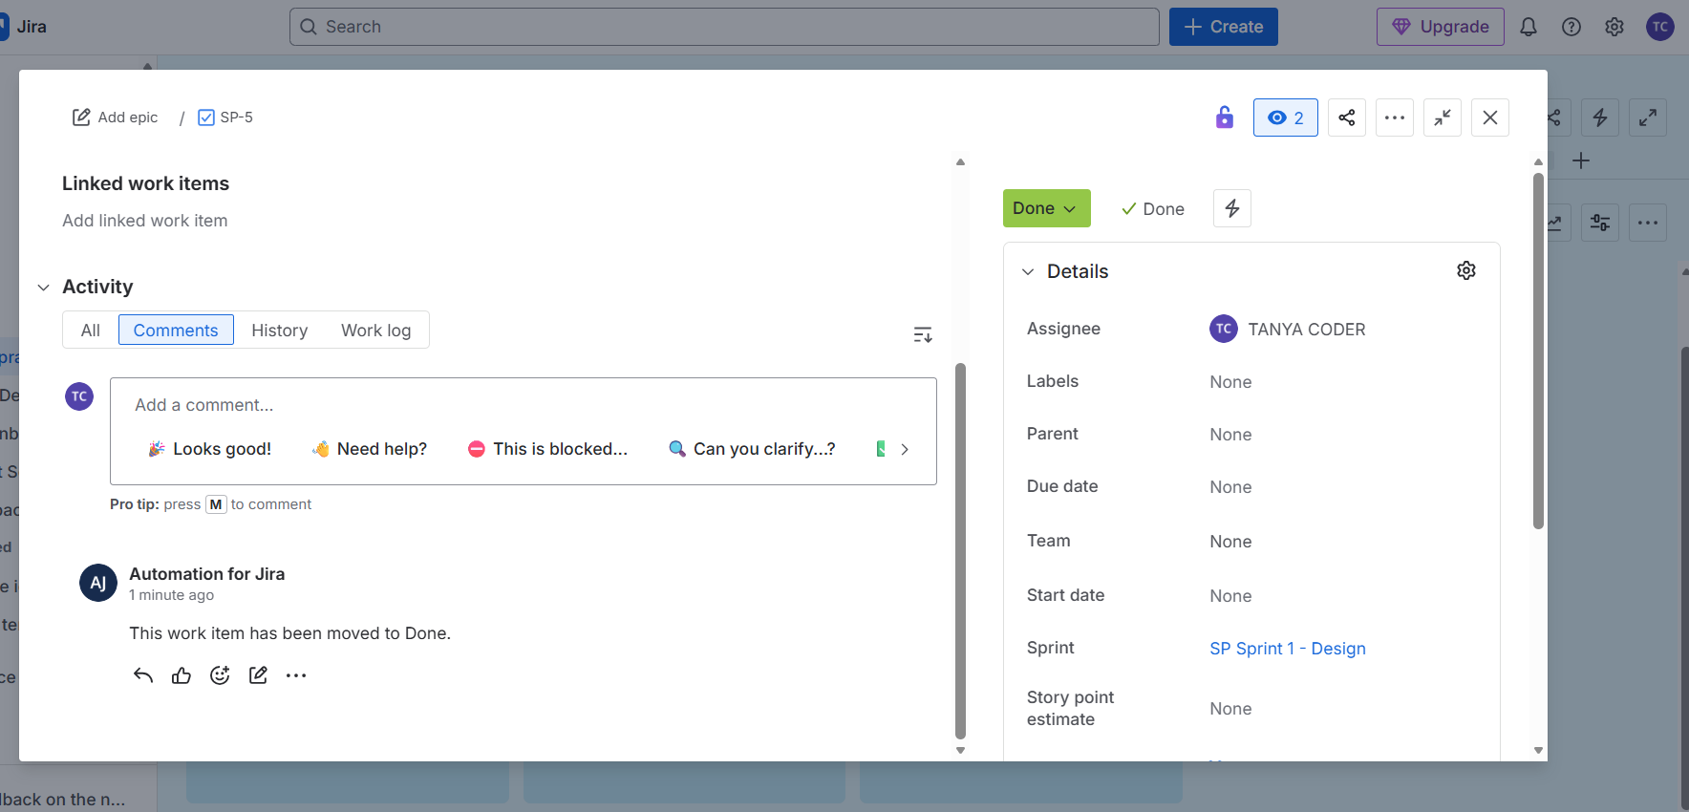

In the above automation, When task moved from to do to done, Assigne is changed and as well as comment has been added.
Automation Successful
Check audit log to see whether the rules you applied are success or not!
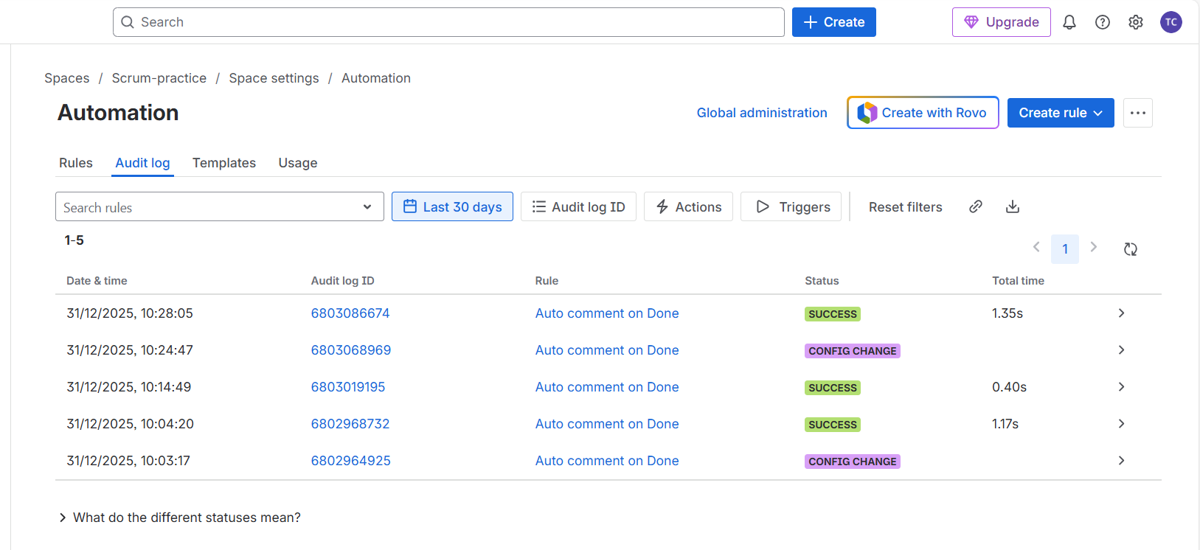
Note: Compliance = compulsory/mandatory rules that need to be followed strictly
Audit = checking whether the rules are being followed or not

New Automation Rule on KANBAN Board : When a Bug is created → Automatically assign it to QA
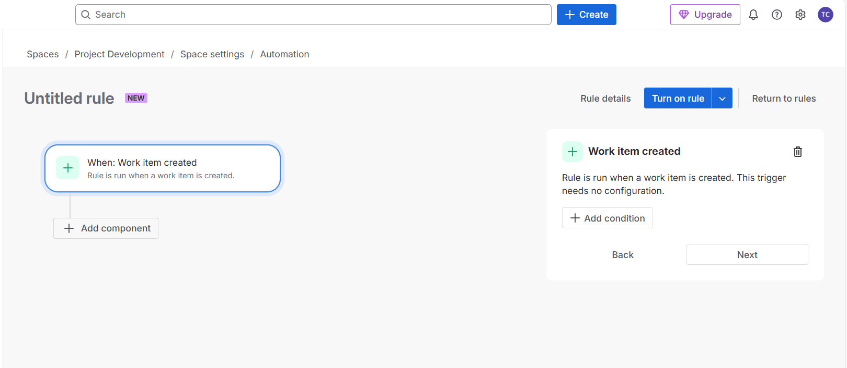
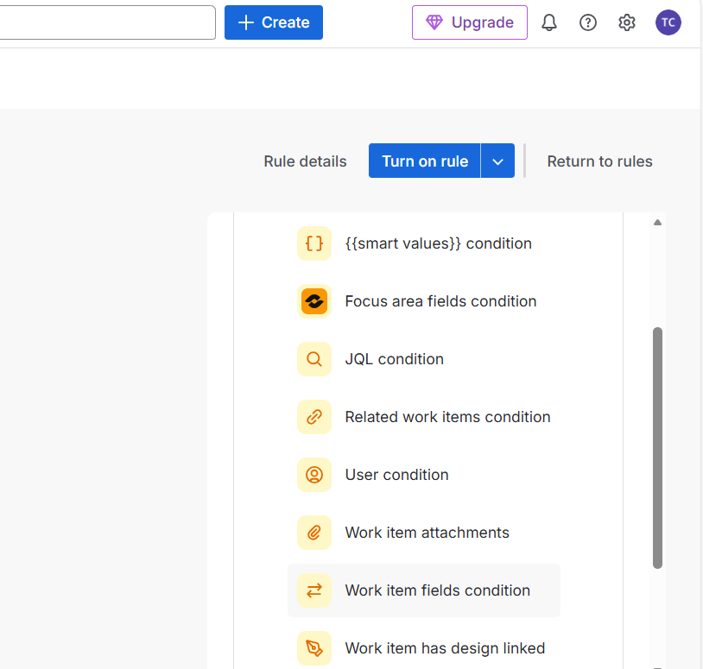

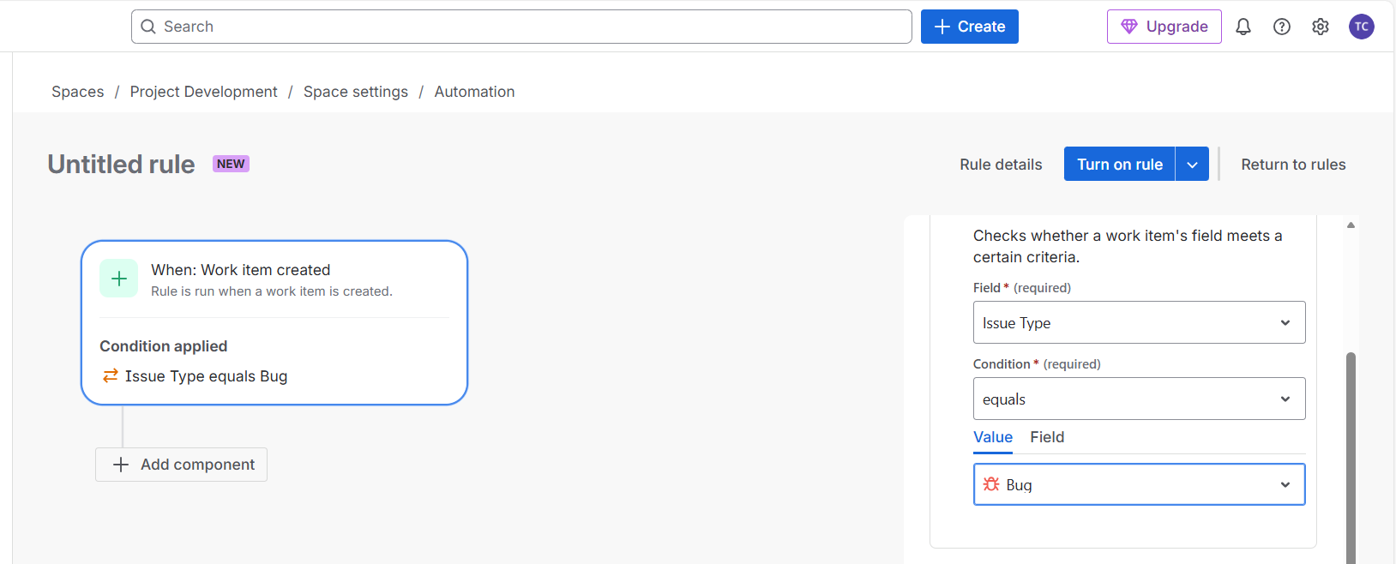

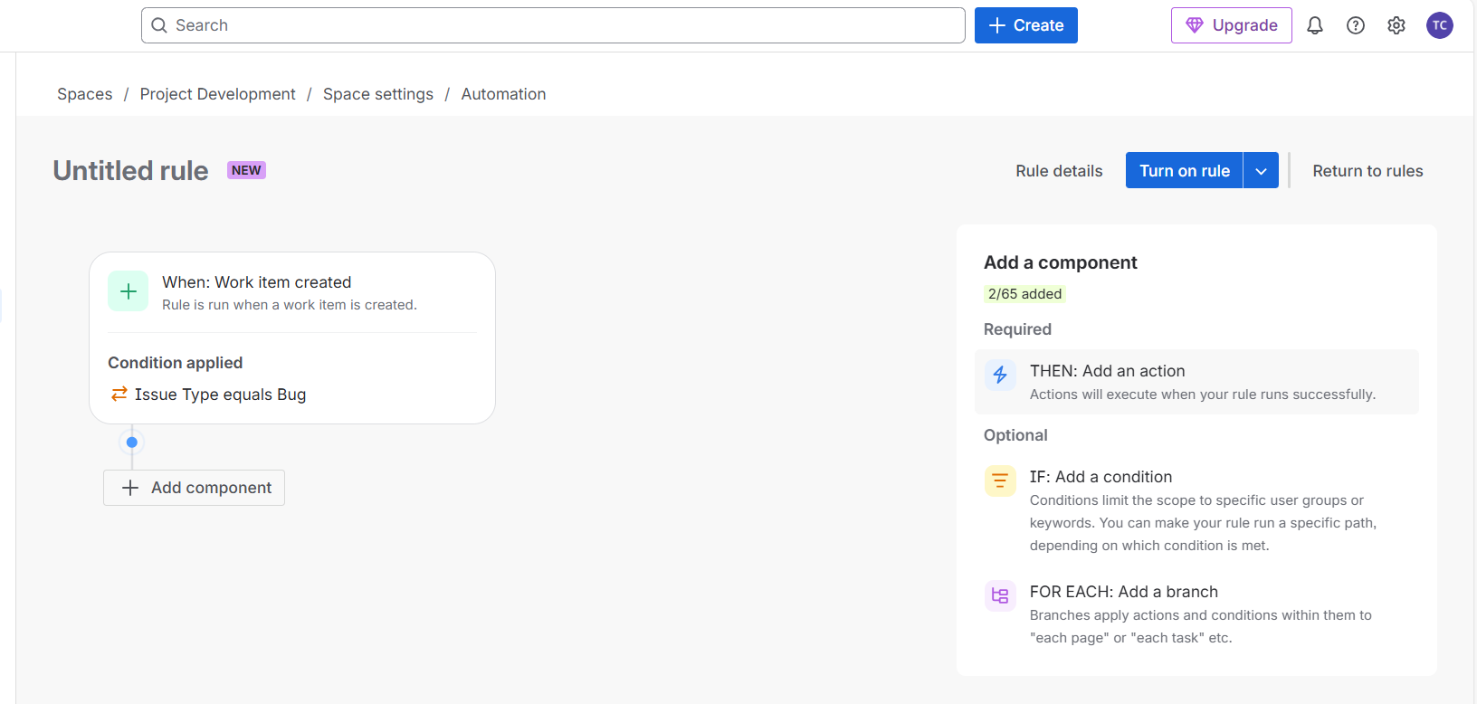
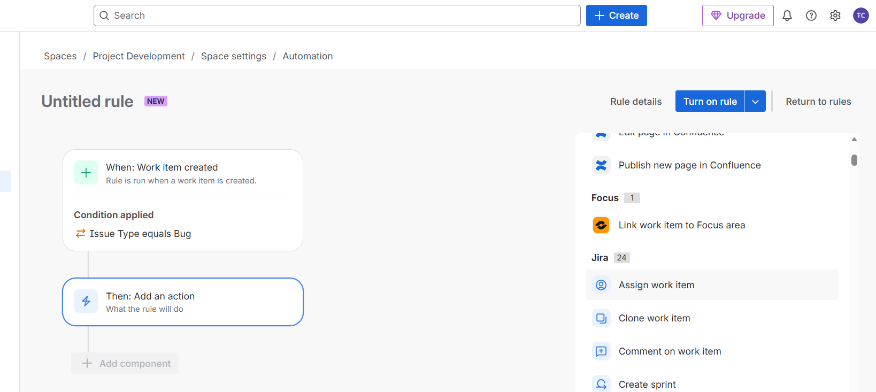

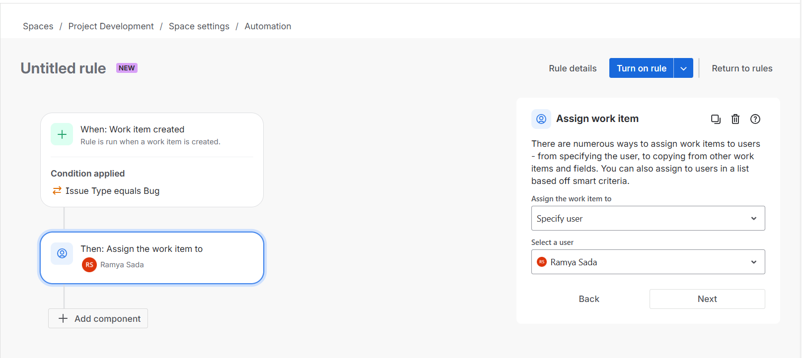

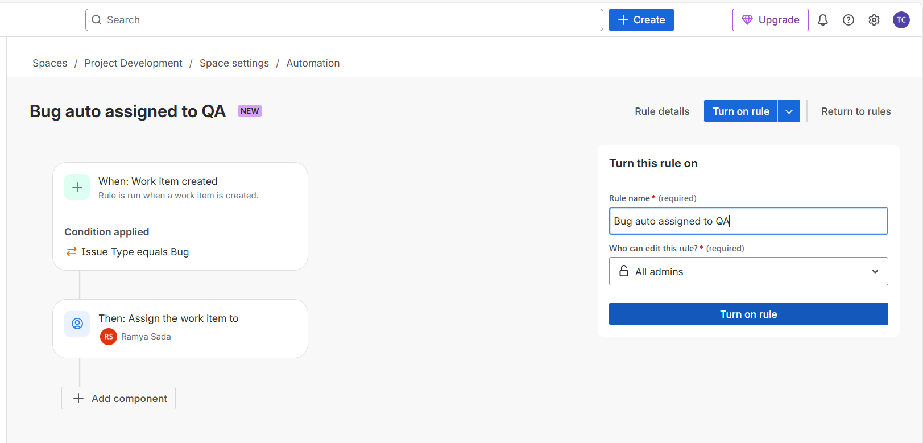
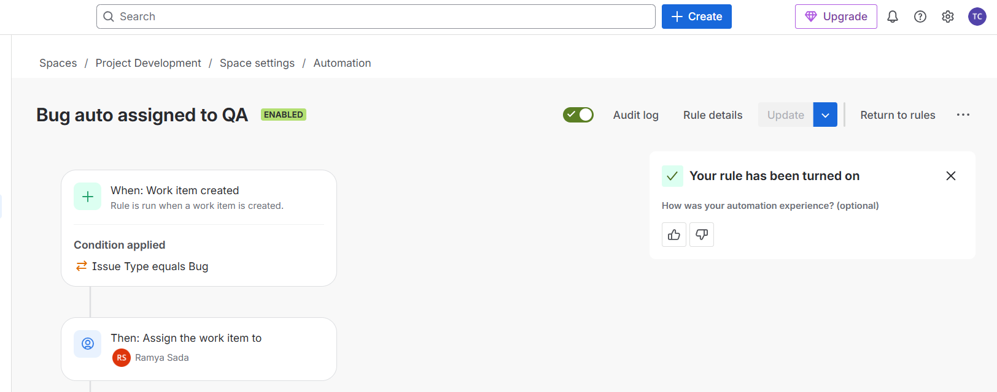

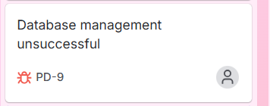

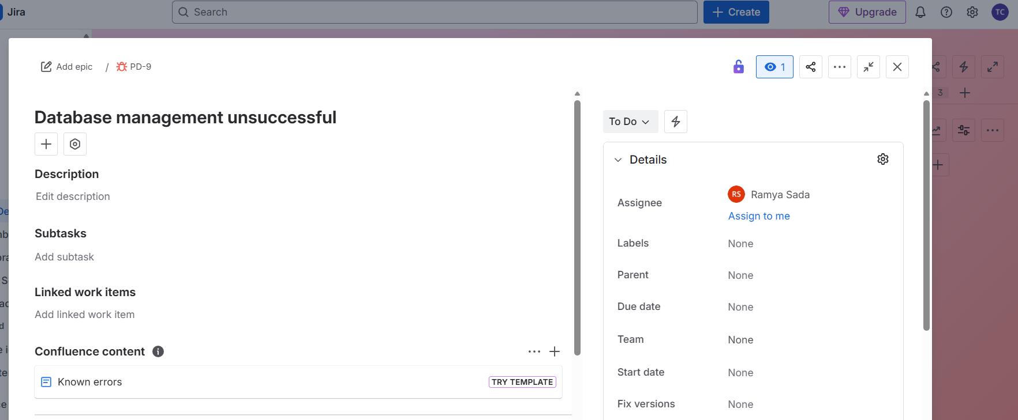

Once bug has been created, it is automatically assigned to specific user that I wanted to!

Why Conditions Matter in Jira Automation
Conditions control when an automation rule should run.
- Without conditions, automation executes for every matching trigger
- With conditions, automation executes only for relevant issues
Conditions prevent unnecessary updates and ensure automation behaves as intended.

Most Used Conditions (Interview Must-Know)
Work Item Fields Condition
Used to restrict automation based on issue data.
Common examples:
- Work type equals Bug
- Priority equals High
- Status is not Done
Typical use case:
- Run automation only when Priority = High
This condition is frequently used to control automation scope.

User Condition
Used to check who created or owns the issue.
Common examples:
- Reporter is QA
- Assignee is not the same as Reporter
Typical use case:
- Run automation only if the reporter is not a developer
This helps differentiate workflows based on user roles.

Status Condition
Used to control automation based on the current workflow state.
Common examples:
- Status equals In Progress
- Status is not Done
This ensures automation does not trigger on completed or irrelevant issues.

IF / ELSE Condition (Advanced Automation)
Allows branching logic within automation rules.
Example:
- If Priority = High
  - Assign issue to Senior QA
- Else
  - Assign issue to Normal QA
This is considered advanced automation and is highly valued in interviews.

Interview Questions (Veeva-Focused)
What is Jira Automation?
Jira Automation is used to automate repetitive tasks such as assigning issues, updating fields, adding comments, and sending notifications based on triggers and conditions.

Is automation project-specific?
Yes. Jira automation can be configured at the project level or global level.
Project-level automation applies only to the specific project in which it is created.
This is a compliance-safe and correct answer.

What are the main components of automation?
- Trigger
- Condition
- Action
These three components define how and when automation executes.

How do you ensure automation does not affect other issues?
By applying conditions such as:
- Work type
- Status
- Priority
- User-related conditions
This ensures automation runs only on intended issues.

How do you verify whether automation executed correctly?
By reviewing the automation audit log, which displays:
- Rule execution status
- Actions performed
- Any errors encountered
The audit log is the primary tool for troubleshooting automation issues.

